<https://pro.nicinvestorsinfo.com/p/CPWLNC/ECPWV700/Full?h=true&fbclid=IwAR1Pfe8ZT1SgUcC29S2-nAR07DjOlax_Y2zZAFGIRe0sje4-DuDyms9AYXE>

Special Alert

New Rule Opens Up Brand New Way to Profit on Marijuana:

Cannabis Lots

**They're already throwing off gains up to 1,000%, even in a matter of hours...**

Noted journalist John Burke has the full details below...

**JOHN:**

Hello, my name is John Burke.



And today, I’m coming to you from the forefront of an economic revolution.

What you’re about to see is nothing less than a transformative breakthrough in America’s fastest-growing industry – the cannabis industry.

In recent years, we’ve witnessed one state after another fight back against a modern-day prohibition.

The voices of the people have grown louder and louder.

* Veterans demanding the freedom to use cannabis as an alternative treatment for PTSD…
* Cancer patients turning to this plant to ease the pain of chemotherapy…
* And even the parents of children stricken with crippling seizures, who have seen miraculous results from cannabis.

Make no mistake; the tides have turned.

In virtually the blink of an eye…

**The U.S. cannabis industry has gone from almost non-existent – to generating an estimated $20 billion in new wealth annually.**

During my 25 years as an investigative journalist…

I’ve joined James Cameron on a submarine journey that took him 2.5 miles beneath the ocean’s surface to explore the 1912 wreck of the Titanic.



I’ve uncovered new clues from the remote Nevada sites where the original atomic bomb tests were conducted.



I’ve travelled to the Great Basin searching for the origins of indigenous cultures that existed over 10,000 years ago.



Each of these events had a profound effect on history… on cultures… on economies.

And from where I’m standing… right here… right now…

**We’re witnessing the next chapter being written for the American cannabis industry.**

You see, even with this unprecedented growth…

**We’ve only begun to scratch the surface of cannabis’s vast potential.**



With the federal government still classifying it as an illegal drug, banks have withheld capital from even the largest publicly traded cultivators and facilities.

This has limited their ability to expand their operations, allocate resources to advanced medical research, and bring new technologies to market.

But recently, the SEC allowed a special “work-around.” A powerful financial mechanism that could change the industry forever.

A mechanism that can help further establish key cannabis companies…

So they can attract capital from outside the traditional banking industry.

And that is absolutely critical.

**What I’m talking about can be called “Cannabis Lots.”**

**Every Thursday at 9:30 a.m., these “Lots” are being offered to the fortunate investors who know how to access them.**

And in return for allocating a few hundred dollars to help the industry tap into capital…

Capital it needs to develop its vast medical, technological, and economic potential…

**Investors have the chance at quadruple-digit windfalls in a matter of weeks, days, and even hours.**

In fact, last January a deal went live where a $500 investment in Cannabis Lots could’ve paid out $17,500 in a single day.

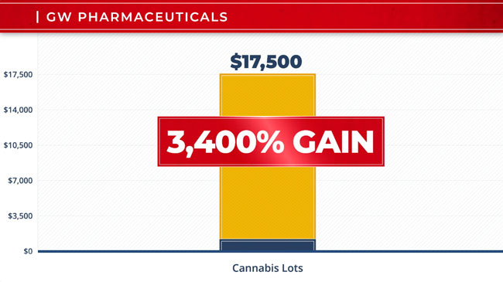

A 3,400% return in 24 hours!

If you’re familiar with our work at the *National Institute for Cannabis Investors*, then you know that our advisory board and our network of experts include…

* A leader on Capitol Hill who is helping design the legislation that will generate new economic opportunities for cities and towns across the country…
* The CEOs of the largest cannabis firms that could soon join the ranks of the blue-chip elite…
* The physicians and scientists developing cutting-edge treatments that could save countless lives…
* The decorated military heroes fighting to bring medical marijuana to veterans who need it the most…
* And the Wall Street insiders uncovering where the money is flowing… and how you can benefit from it.

**We are the leaders of the cannabis revolution.**

**According to our historical backtest, we have already uncovered 64 stocks that have delivered windfalls of 1,000% or greater.**

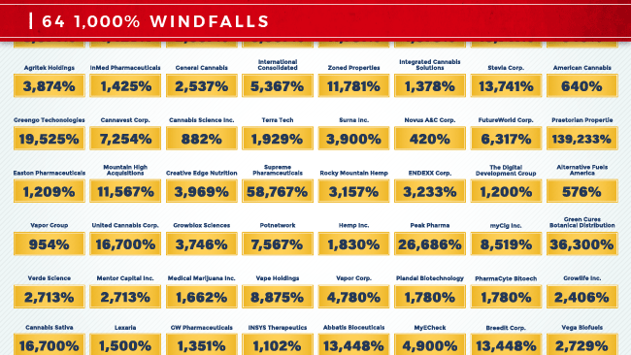

We’ve received letter after letter from Americans describing how we’ve helped them quickly add tens of thousands – even hundreds of thousands – of dollars to their net worth and retirement accounts.

And now, we’re going to take things to the next level.

**Today, I’m joined by one of The Institute’s top experts – he’s been called America’s #1 Pattern Trader.**

He’s also the co-founder of a large cultivation operation in Florida that will provide cannabis treatments to military veterans.

**Together, we’re going to reveal everything you need to know about Cannabis Lots.**

What are they?

How do they work?

And how ***YOU*** can capitalize on Cannabis Lots that can repeatedly transform a few hundred dollars into thousands – even tens of thousands of dollars – sometimes in as little as one day.

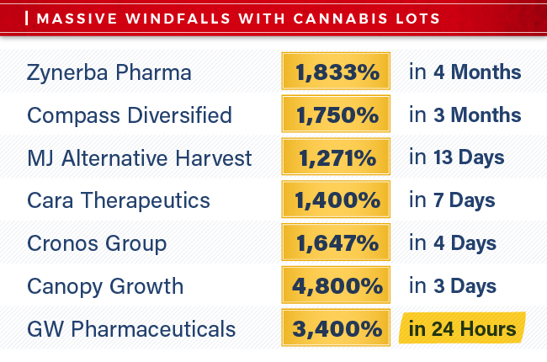

Finally, we are going to do something incredible together.

**We’re going to release $1.5 million in funds so folks just like you can take advantage of Cannabis Lots.**

So without further delay, let me introduce you to Tom Gentile.

Tom, thanks for joining us.

**TOM**:

Glad to be here, John.



We’ve got some big news to discuss, and I couldn’t be more excited.

**Cannabis Lots could revolutionize this industry.**

**JOHN:**

And this is a very, very recent development.

**TOM**:

It is.

**The SEC just gave some of the major players the green light to offer Cannabis Lots to investors.**

This happened literally just a few months ago.

I can’t overstate how important this is.

The U.S. cannabis industry is a mess.

* 33 places in this country – individual states and Washington, D.C. – have already legalized medical cannabis.
* 11 have approved both recreational and medical use.

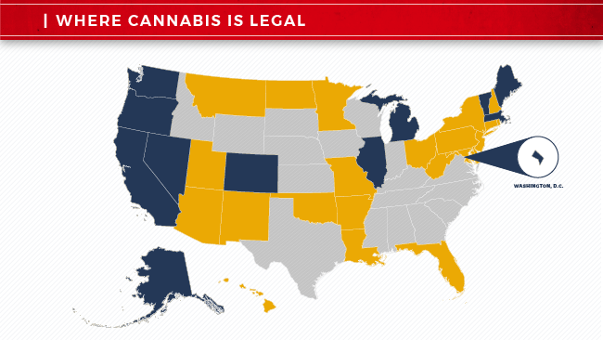

**Yet it is *still* illegal at the Federal level.**

This is crazy.

**JOHN:**

It’s certainly been scaring off many everyday investors from jumping into what the press has called a modern-day gold rush – or green gold rush.

**TOM**:

But wait – it gets even better…

The federal government is trying to enforce federal cannabis regulations…

But Congress isn’t having it.

**For the last – I believe – five years, Congress has voted repeatedly to block the Feds from going after states.**

And it just happened again this past June.

**JOHN:**

So basically, a large number of states have taken matters into their own hands.

Some have said, “*We’re legalizing just medical marijuana*…”

Others have said, “*We’re legalizing everything*…”

**TOM**:

But the federal government still insists that this is illegal.

And then Congress – who are members of the federal government, right?

Congress said to the Feds, “*Hold up*–*we don’t care if it’s illegal*–*we’re not allowing you to enforce federal law. And if you even think about disobeying us, we’ll cut off your funding for drug enforcement. State law rules*–*period*.”

Yeah – I’d say this could cause some confusion with investors.

The bigger issue, though, is the banks.

**Federally regulated banks – with all that confusion – they can’t provide funding to cannabis companies, big or small.**

**JOHN:**

But it hasn’t stopped the industry from becoming this massive wealth generator.

**The money in play keeps multiplying over and over.**

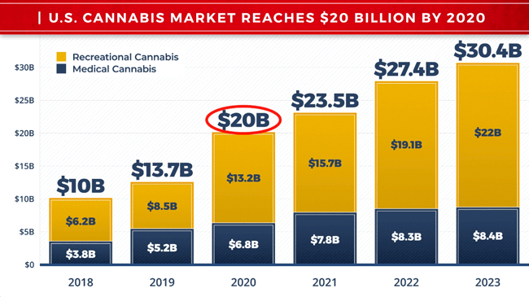

Projections are coming in at $20 billion – by the end of next year – from cannabis businesses just in the U.S.

**TOM**:

Incredible amounts of wealth are being created from cannabis stocks too.

In the early days, you had these penny pot stocks flying up tens of thousands or hundreds of thousands of percentages – on little more than rosy press releases with hopes and dreams sprinkled on top.

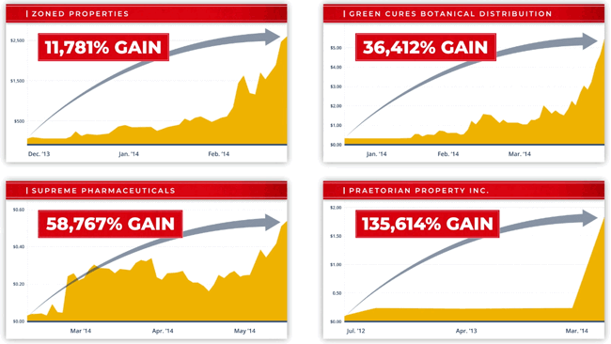

Out of the blue, companies were going public on the pink sheets or tiny exchanges in Canada.

**Initially, a lot of people made a lot of money from all this confusion.**

**The stories of overnight marijuana millionaires became headline news.**

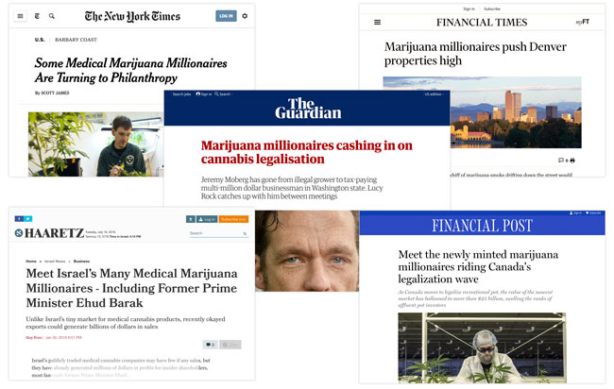

Nevertheless, speculative investments can make someone rich very quickly if they catch the right breaks.

And many did.

Then, the market began to mature.

Everybody collectively decided they wanted to get out of this Wild West phase.

And we began to see the major players IPO on the NASDAQ or New York Stock Exchange.



And Wall Street began to cover and invest in cannabis stocks.

But there was still massive confusion on the traditional banking side.

**That’s because federally regulated banks can’t touch cannabis companies with a 10-foot pole.**

Until…

**Wall Street offered up a “work-around” in the form of Cannabis Lots.**

They said, “*Since 1973*,*a variation of these lots has played a major financing role with household-name companies. Give us a shot with them*.”

And the SEC allowed it.

And that’s where we’re at today.

**JOHN:**

Tom, we’re going to dive into Cannabis Lots in just a little bit.

First, though, I want to talk about you – in case somebody watching isn’t familiar with your story and your credentials.

**TOM**:

That sounds great.

But really quick, before we get into all of that, I just want to demonstrate how lucrative Cannabis Lots can be.

John, this is just mind-blowing stuff.

**Take Cronos Group.**

One of the first to offer Cannabis Lots to investors.

They’re an enormous player in the cannabis industry.

Cronos has cultivation operations in Canada, Australia, and Israel…

Its stock trades on the NASDAQ.

Market cap was a little under five and a half billion dollars.

Now, rewind back to last December – the morning of December 3.

I wake up nice and early – it’s a cloudy and rainy day down at my house in Sarasota.

**JOHN:**

Not ideal for going out on your boat or driving around in one of your convertibles.

**TOM**:

Yeah – boat was staying at the dock that morning – cars in the garage with the tops up.

9:30 a.m. rolls around.

**Wall Street rings the Opening Bell – Cronos’s stock starts trading.**

You could’ve bought those shares if you wanted to right then and there.

If you knew how, though, you could’ve invested in the Cannabis Lots instead.

**Those Cannabis Lots would’ve cost you $480.**

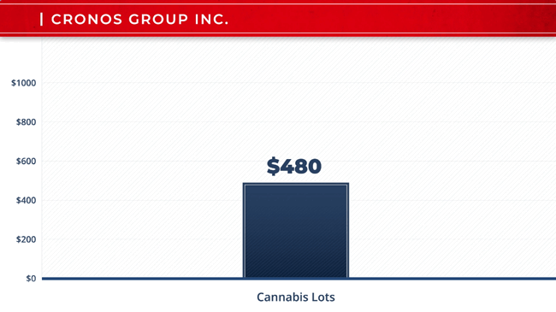

Fast forward to December 7...

**John, your Cannabis Lots are now worth $15,424.**

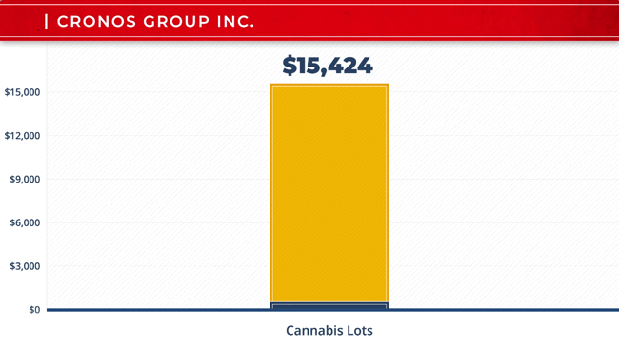

We’re talking just four days in the future.

**JOHN:**

It’s a stunning amount of money.

**TOM**:

**John, you would've collected a 3,113% windfall in four days.**

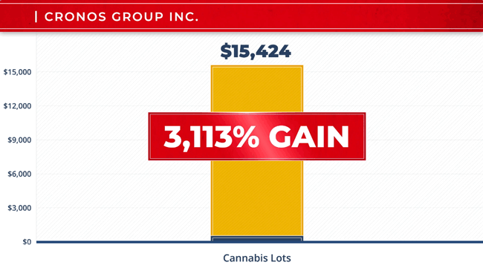

You’re *on the board* with me at The Institute – you know all about Cannabis Lots.

You’re underselling this.

If this is the first time you’ve invested in Cannabis Lots – you would be stunned.

**JOHN:**

All jokes aside, what if I’d never heard of Cronos’s Cannabis Lots?

What if I just put my $480 in the stock instead?

**TOM**:

You would’ve still made a pretty decent return – at least when you’re looking at it as a percentage.

But as an actual dollar amount – it would’ve been nothing to write home about.

**Between December 3 and December 7 – Cronos’s stock jumped about 38%.**

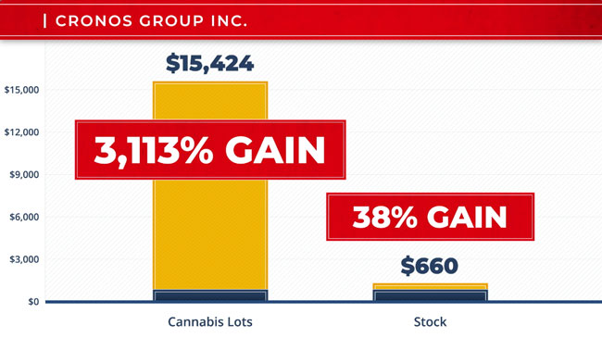

Your $480 would’ve grown to $660.

**JOHN:**

Pretty lopsided choice.

**Would I rather transform $480 into $15,424 by investing in Cannabis Lots…**

**Or $660 by investing in the stock itself?**

Pretty easy decision.

**TOM**:

Extremely easy once you know how to invest in Cannabis Lots.

I’ll give you another way to look at it.

You would’ve had to risk $11,216 on Cronos’s stock to get that same $15,424 payday.

But again – with Cannabis Lots, you only needed to put $480 on the line to pocket that $15,424.

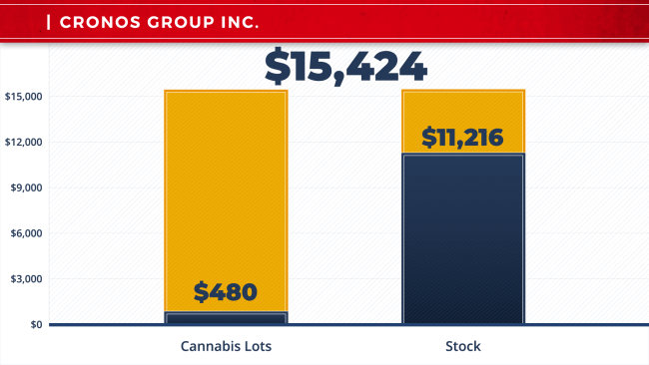

**You could have made a 23X bigger payday with Cannabis Lots… and risked a whole lot less.**

The decision just became even easier.

**JOHN:**

Okay, Tom.

In just a few moments…

**We’ll go through all the major points with Cannabis Lots.**

Folks watching, I’m sure have some big questions.

**We’ve also got that $1.5 million we’re putting up to help them hit the ground running.**

But as I mentioned… first, we need to talk about you.

**TOM**:

Fire away, John.

**JOHN:**

You’re known as America’s #1 Pattern Trader.

**You’re a go-to expert on the markets for CNBC, *Bloomberg*, *Reuters*, Fox Business, you name it.**

And some might say you live a life of extreme affluence…

* Fancy cars, boats, a mansion in Florida for the winters…
* A home in the Hudson Valley in New York for the summers…
* A getaway spot in New Zealand in a neighborhood called “Billionaires’ Row…”
* You’re also a philanthropist – donating huge amounts of money to charities you support like the Leukemia and Lymphoma Society, the Los Angeles Fire Department, and the North Shore Animal League.

**TOM**:

John, I’m not ashamed of my success. So yeah, I do enjoy the finer things in life. I make no apologies for it.

And I’m a big believer in giving back and paying it forward.

**Because hard work and brains play a big role in whether or not you become rich in America, but luck, catching some breaks – just as important.**

And nothing was handed to me – ever.

But when I caught a lucky break, I took advantage of it.

You see, I grew up outside of Pittsburgh – in a small mining town.

I don't have a college degree.

But it turns out I didn’t need one.

So, it’s the 1980s…

I’m down in Atlanta working at one of Home Depot’s first stores.

**JOHN:**

First stores in the entire country – wearing the orange apron.

**TOM**:

Of course. I was in customer service… stocking shelves… I was a forklift operator…

I did it all.

Back then, there were just a couple of Home Depot stores.

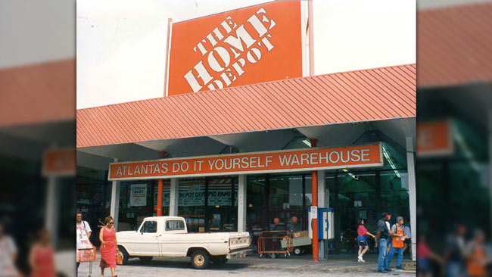

They didn’t have the fancy computer systems they have now.

Just a bunch of us running around trying to figure out how many hammers to order to stock the shelves.

But here’s the thing.

**I’m one of those guys who is always tinkering with things… breaking things… opening them up… seeing what makes them tick.**

And it's the ’80s – all programming was basic back then.

One day, while working in the warehouse, I wondered whether or not I could just build a piece of software that would look at all the sales from prior months and years and predict how much of any item we should order at any specific point in time.

What if we could just push a button on a computer, and bam!

The answer is on the screen.

I pitched the idea to the guy who ran our IT department.

He loved it.

And we built the program.

Within two years, Home Depot opened 100 new stores.

**JOHN:**

You must’ve been pretty popular at headquarters.

I’ve seen pictures of you with billionaire Arthur Blank in his private suite at Atlanta Falcons games.

He owns the Falcons and is a co-founder of Home Depot.

**TOM**:

I think I made an impression on Mr. Blank; that’s for sure.

But more importantly, I wondered whether my program could be applied to other things.

Like the stock market.

I was already spending my nights trying to figure out how to smartly invest the little I had.

After paying my bills, it wasn’t more than pocket change in those days.

So…

**I modified my program to work on stocks.**

You know – could it detect certain points in the year where a stock, for whatever reason, would go up or down.

**I never liked the idea of “buy and hold” investing.**

Why park your money for years or decades in a stock hoping it pays you eventually when you know that during this two-week window every year, for the last 10 years, that stock goes up.

So I can just buy it at the beginning of that two-week period – sell at the end – move that money into the next stock, and so on.

**My upgraded program proved to be 90% accurate at spotting these windows in time.**

And it still works great today.

**JOHN:**

Wall Street heard about what you were doing – you were talked about in a ***Wall Street Journal*** article – then a major firm ponied up $20 million to purchase what you developed.

**TOM**:

$20 million, that’s correct.

They benefited greatly from it.

But at the end of the day, the technology was mine.

I had filed a patent on that invention and never looked back.

So I kept going with it.

**It was great at making money quick from blue-chip stocks.**

My invention would process huge amounts of data going back 10 years, looking for those small windows.

**Then, when cryptocurrencies became hot, I wondered if my invention could be refined to spot small windows of time to invest in these digital coins.**

The challenge was that Bitcoin has been around for about 10 years – but most of these cryptocurrencies popped up on the scene very recently.

The data was somewhat limited.

Fortunately, my programming days were behind me.

**I have an army of data scientists and machine learning experts working for me.**

**Real rocket scientists: MIT- and Harvard-level geniuses.**

Here I am, this guy from nowhere with no college degree – and these guys are on my team.

**JOHN:**

Billionaires Mark Zuckerberg and Bill Gates both dropped out of Harvard – they didn’t need a college degree.

**TOM**:

Harvard would’ve tossed my application in the trash if they had seen my grades out of high school.

Anyways, my team figured out a way to uncover these patterns with a bunch of cryptocurrencies.

**We upgraded my invention, flipped the switch…**

**And BOOM! Every closed trade I targeted was a winner. Every single one.**

Next up – cannabis stocks became the latest craze.

**The industry has had me intrigued for some time – I have buddies who are veterans.**

They talk about how they come back home after serving our country, and they’re suffering from PTSD, severe pain, and sleepless nights.

They don’t want all the drugs the doctors are prescribing.

And many of them are using cannabis.

**I got into this industry to see if I could help them.**

So I partnered with a doctor and good friend of mine to build a medical cannabis company in Florida.

And I’ve been an angel investor in the space.

I wanted to know the ins and outs of this industry.

That way, when I upgraded my program again, it would be able to spot patterns with publicly traded cannabis companies.

However…

**I wasn’t interested in the stocks.**

**I targeted opportunities with Cannabis Lots.**

And that’s what I’m doing now.

**JOHN:**

Well no one, including the SEC and big investing firms, are about to go out of their way to let ordinary investors know about this development.

But as you’re about to prove, Tom…

**There’s nothing stopping the average Joe from tapping into this extraordinary new profit stream…**

**And potentially making thousands or tens of thousands every week.**

**TOM**:

That’s exactly right.

**Take a look at Aurora Cannabis.**

It’s an international growing operation.

Stock uplisted to the NASDAQ in October.

Now, they’re getting more online investors than tech giants like Apple!

**Rewind to the morning of March 4, shortly after the SEC allowed Cannabis Lots on Aurora. Their Lots were selling for just $15 each.**

Let’s say you snap up 33 Lots.

Your cost?

A mere $495.

**11 days later, you could have sold those same Lots for $7,194.**

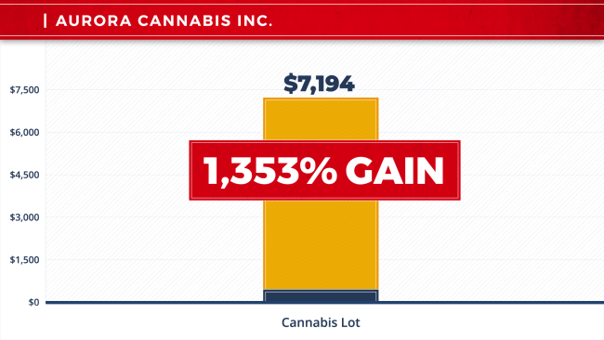

**That’s a 1,353% gain in less than two weeks.**

**JOHN:**

That’s impressive.

What about the stock?

**TOM**:

The stock?

Not so much.

Put your same $495 on the stock, and your gain was just 37%.

Instead of over $7,000, you’d have been looking at a $183 profit.

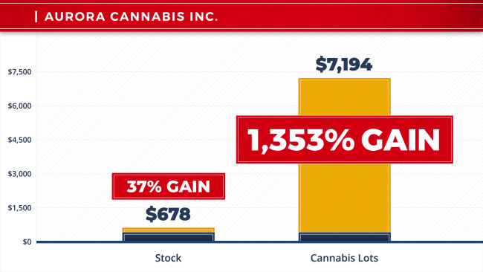

That’s nothing compared to what a beginner could have done with Cannabis Lots investing my way.

**JOHN:**

That’s hardly worth writing home about.

**TOM**:

Look at it this way…

**You’d have to pony up over $5,000 on the stock…**

**Nearly 10X the cash, just to make the exact same payday you got with the Lots.**

**JOHN:**

So just to recap…

**You could put up as little as $495 and walk away with $7,194…**

Or, you could settle for the $183 consolation prize.

**TOM**:

John, you’ve got it.

Now, let me show you another one…

**I’m sure you’ve heard of Canopy Growth.**

**JOHN:**

Of course, they’re one of the original founders of the cannabis industry.

**TOM**:

Well, Canopy Growth’s all grown up now.

They uplisted to the New York Stock Exchange last May.

A few months later, after the SEC allowed them to begin offering Cannabis Lots…

**You could have grabbed four of their Lots for just $500. 19 days later, you could have cashed out for $6,844.**

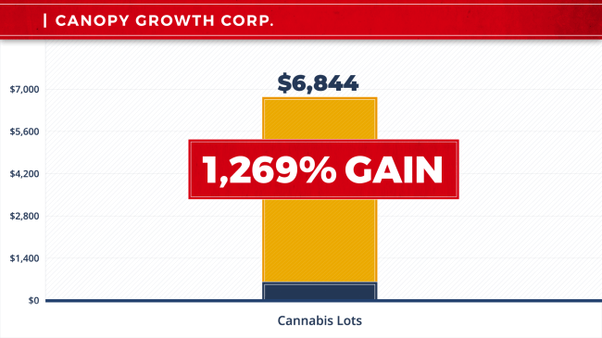

That’s a 1,269% gain in less than three weeks.

**JOHN:**

I’m guessing the stock wasn’t as impressive?

**TOM**:

Actually, the stock made a nice move.

Jumped 52% in the same time period.

But if you wanted to take home that same $6,844 payday…

You would have had to cough up nearly $4,500.

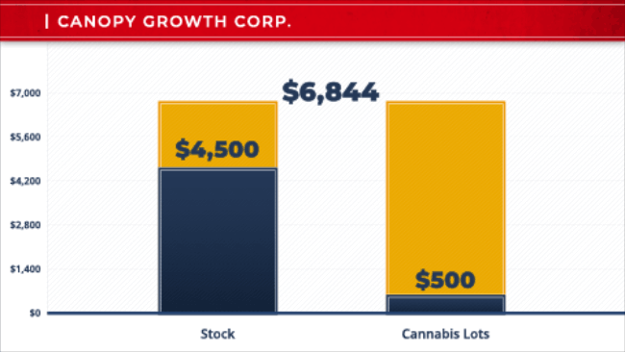

**Ask yourself: Why would you risk 9X the cash if you didn’t have to?**

Just doesn’t make sense.

That’s why I’m targeting these Cannabis Lots.

**JOHN:**

Tom, you’re throwing out some really impressive numbers here.

**You’re talking about profits of…**

* **3,113%...**
* **1,269%...**
* **1,960%...**

**All in less than 35 days.**

**TOM**:

These gains are rare and exceptional. They do not happen every day.

But I could go on and on.

**And the number of different Cannabis Lots you can buy is skyrocketing.**

**Every week, two to five NEW Cannabis Lots will be made available to the public.**

**JOHN:**

Now Tom, before we get into the mechanics of how these Lots work…

I just want to pause for a second and give folks a little background here.

The idea behind these Cannabis Lots?

It goes all the way back to ancient Greece.

**TOM**:

That’s right.

This isn’t a new idea.

It’s been used by shrewd investors for centuries.

It’s just new for cannabis investors.

**JOHN:**

If I’m remembering my Greek history right…

There was this philosopher named Thales of Miletus.



He was convinced that there was going to be a massive olive harvest.

No one knows why to this day, but he was absolutely sure of it.

And he’s thinking… how can I make some money on this?

Because he doesn’t own any olive trees…

So he goes around to all the owners of all the olive presses.

And he says to them, “I want to rent out all your presses now for the upcoming harvest.”

Of course, they thought he was crazy.

Why would anyone pay before the fruits are even ripe?

He basically rents out the entire inventory of presses*before* the harvest.

Of course, the harvest turns out to be huge like he thought.

And every olive grower has to pay *him* a premium to press their olives.

Thales… he makes out in spades.

All without ever owning a single olive or a single press.

It’s the easiest money you’ll ever make… if you know how to get it.

**TOM**:

John, you’re absolutely right…

**This is the easiest way to make money I’ve ever seen in my life.**

These Cannabis Lots give ordinary investors a way to profit from this massive growth in the cannabis industry.

Without ever growing cannabis or processing it or harvesting it themselves.

**It’s a win-win for everyone.**

**JOHN:**

So Tom, let’s get into how this works.

**What exactly are Cannabis Lots?**

**TOM**:

It’s pretty simple, John.

**They are a type of newly issued options on select cannabis companies.**

Many of them weren’t available until just a few months ago.

But today…

**These Cannabis Lots are right in my “sweet spot.”**

Now, I’m not talking about those complicated, risky kinds of complex strategies that many people have heard about.

Instead, with the way I trade…

**Cannabis Lots can be drop-dead simple…**

**Some of the easiest transactions you’ll ever make in your life.**

And here’s how it works…

Let’s say, just like Thales, that we know that a particular cannabis company is about to skyrocket.

* It might be that their brand is taking off…
* It could be they are opening up a new market…
* Maybe they’ve invented a new self-contained growing technology…
* Or the company is acquiring licenses for distribution in California…
* Or they’re opening a new business on the Vegas strip…
* It could be their exports are doubling or tripling…
* Or maybe they’re acquiring or merging with a big company…
* Maybe they’re about to be bought out by a huge conglomerate like InBev.

**It could be anything; it doesn’t matter.**

Now, most people could go out and buy the stock.

But that could be a first grader’s move when you consider…

**One, you need only a TINY fraction of the cash…**

**Two, you risk way less money…**

**Three, you can make up to 50 times more money on your move…**

**Four, profit in most cases comes in one-tenth of the time.**

**And five, you can do it over and over again.**

That’s how you can do it with Cannabis Lots.

**Take a look at the MJ Alternative Harvest.**

You could have put $5,000 in the stock in 2018.

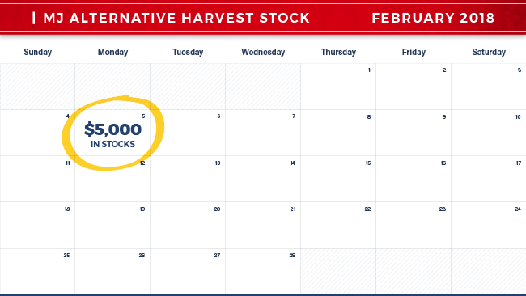

**Then, 14 months later, you could have banked $1,114 in profits.**

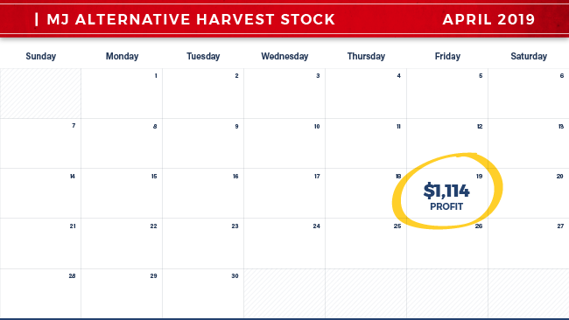

Or, you could have bought five MJ Lots instead.

That would have cost you just $500.

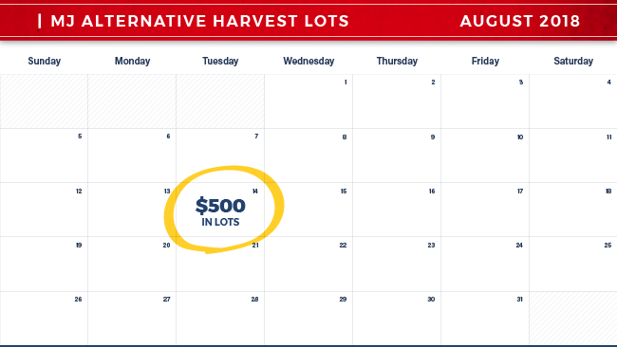

**After only 34 days, those Lots could have handed you $9,800 in profits.**

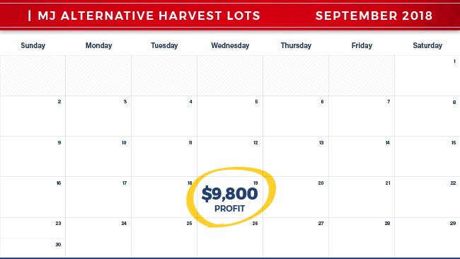

Meaning…

**You could have made 10X the cash at one-tenth the cost…**

**In a fraction of the time.**

It’s a no-brainer.

**JOHN:**

That’s beautiful… so you would have put up less and made more.

**TOM**:

Exactly.

**Now, let’s talk about Tilray.**

They were the first cannabis stock to IPO on the NASDAQ in July.

**The stock shot up 640% in about three months.**

Now, that’s a really nice run.

But the Cannabis Lots?

Are you ready?

**You could have made 1,350% in less than one month.**

Let me break it down for you…

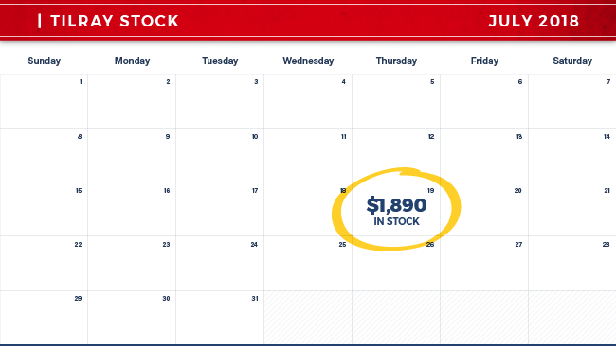

Had you invested $1,890 in Tilray shares, you could have been looking at around $12,000 in total gains.

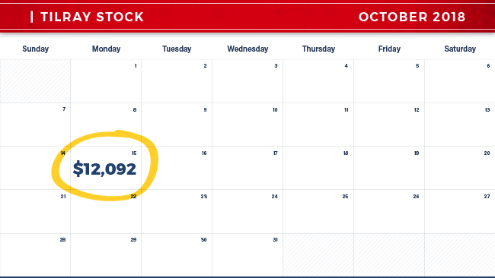

Now, that doesn’t sound bad until you consider that…

**Had you invested that same amount in one single Tilray Cannabis Lot…**

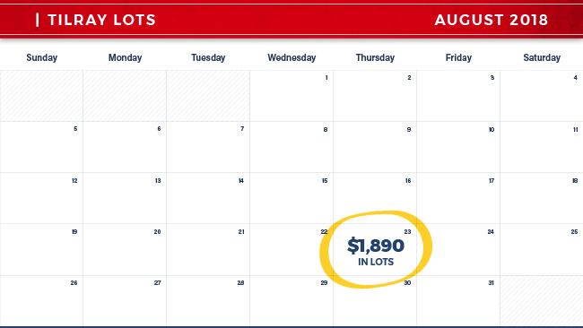

**You would have been looking at $27,405 in one month.**

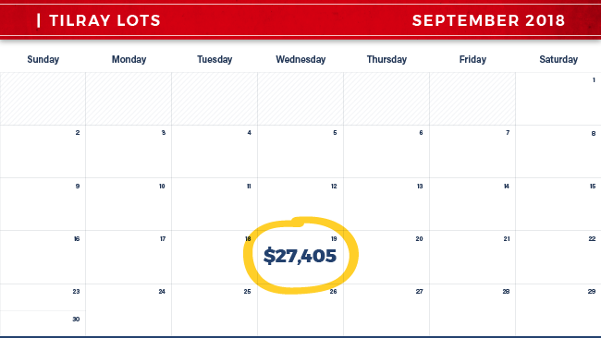

**JOHN**:

That’s nearly double the cash – in this case, in one-third the time!

**TOM**:

**If you think that’s great, then take a look at Aphria.**

They’re a major Canadian company selling medical-grade cannabis around the world.

When Aphria first began trading on the New York Stock Exchange, you could have put $4,250 in the stock...

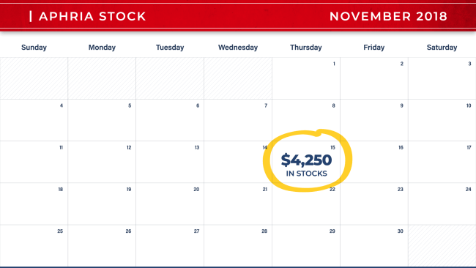

And you would have been looking at all of $227 in about three months.

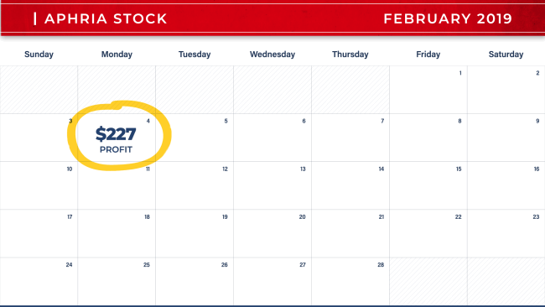

Kind of a snooze fest…

But if you had waited until the SEC allowed Aphria to offer Lots instead… you would have paid just $425…

And you could have been looking at $12,325 in only 13 days.

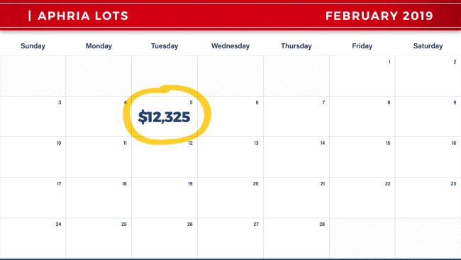

**That’s more than 50 TIMES the cash at one-tenth the cost.**

In days, not months.

That’s the power of these Cannabis Lots.

**JOHN:**

Now Tom, this is all brand new.

And these gains… they’re breathtaking.

And you’re telling me this isn’t something you need any special license to trade or any special knowledge at all.

**TOM**:

John, this is not some elite, convoluted system.

**Absolutely anyone can take part in making money here in about 10 minutes.**

Any single person who can see the writing on the wall with cannabis (and the amount of money being set up to be made here) can finally take advantage of it.

Look, a lot of people are getting into cannabis stocks.

And they’re doing pretty well.

But…

**If you want to go “all in” on cannabis for a tiny grubstake and potentially make a fortune fast…**

**Then Cannabis Lots are a great way to do it.**

**JOHN:**

Tom, as you already know…

**Our mission is to help people make money on cannabis.**

**It’s why we built the *National Institute for Cannabis Investors*.**

And you’re helping us accomplish that goal.

**It’s also why we’re giving out $1.5 million in funds to *prove* this can be the fastest way to make money in the cannabis space today.**

Tom, what we’re seeing here is amazing.

Yet I have to say: Like anything in life, not everything just goes up, right?

I mean, every investment has its ups and downs.

And no one in their right mind wants to buy anything unless you’ve got a pretty good idea that it’s about rocket, right?

**TOM**:

No doubt.

I cannot sit here and tell you that every Cannabis Lot is going to go up.

**No one should ever risk a penny they can’t afford to lose.**

**In my book, every penny is precious.**

**JOHN:**

So why should people consider these Cannabis Lots?

**TOM**:

For two reasons, John.

One…

**There is so much money that can be made here – and so fast.**

**After the SEC began allowing trading on these Lots, my system pinpointed 10 different plays right out of the gate.**

It found a bunch of doubles and triples like 201%, 270%, and 311%...

It found 676% gains, 761% gains, and even 1,350% gains…

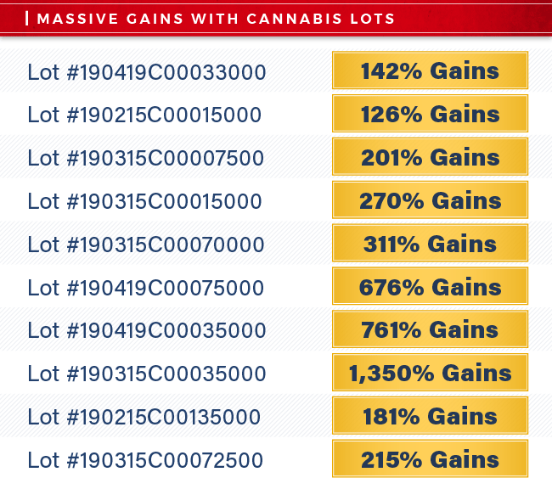

And this was all in one month alone.

**JOHN:**

Like I’ve been saying: The profits on Cannabis Lots can be breathtaking.

**TOM**:

There’s a reason the numbers are so amazing.

**And it leads directly to my number-two reason I love to trade Cannabis Lots: Patterns.**

**JOHN:**

Tom, I know you’re considered America’s #1 Pattern Trader, so that makes sense.

**TOM**:

You bet it does.

**There is nothing more powerful in nature – and nothing more powerful in trading – than uncovering a hidden pattern.**

Like any sequence, a pattern tells you what’s coming next.

Like if I give you a series of numbers like 4, 8, 12, 16…

You know the next number to come is 20.

It’s a sequence of 4s.

Picking the right Cannabis Lot is no different.

Most often it can be right in front of your very eyes.

**JOHN:**

You mean, if I can figure what number comes at the end of a sequence like 1, 3, 4, 7, 11… then I can make a lot of money?

**TOM**:

That’s right, John…

It’s what enables me to so accurately predict future events.

Like in that sequence… where you just add the two previous numbers… in this case, the next number would be 18.

That’s exactly the way it is with Cannabis Lots.

The only difference is that obviously there’s a ton more data behind it… and these patterns may involve thousands – even hundreds of thousands – of variables.

**These Cannabis Lots… they can be unlocked with five different patterns.**

**JOHN:**

What kind of patterns are we talking about?

**TOM**:

**First, there’s what I call the Triple Threat.**

My system looks for a very specific crossover point of the 10-day and 30-day moving averages.

And it could put some serious cash in your pocket, fast.

Take a look at this chart of the Triple Threat, and let me show you what I mean.

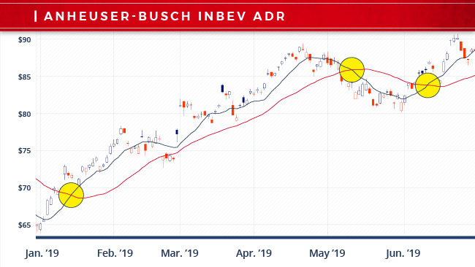

See, you can distinctly see where the crossover occurs at the upside, as well as the downside.

Guess what?

The stock is off to the races.

**Second, there's the Channel Collision.**

My system tracks the long-, short-, and intermediate-term trend channels.

What we're looking for here is a specific pattern of highs and lows.

**When these channels collide, it's a very, very powerful signal.**

**These plays can be superfast, and you can be in and out in less than a week.**

Here's a great example of a recent collision play.

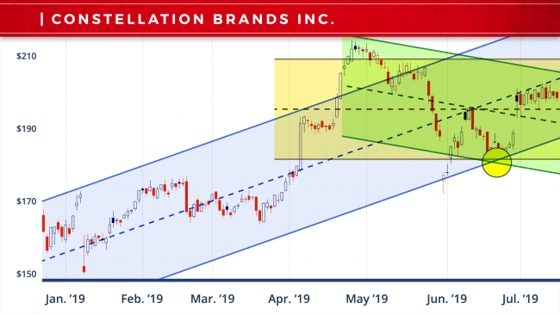

As you can see, this chart was moving higher.

You can tell that by the long-term channel.

The intermediate-term channel is moving sideways, noticing a pause in this trend.

The short term shows a pullback.

Notice where all three intersected at specific support points. This is the buy signal for this particular system.

**Third, there are powerful volatility patterns.**

What these patterns tell us is whether these Lots are cheaper or more expensive and if it's the right time to buy or the right time to sell.

Take a look at this.

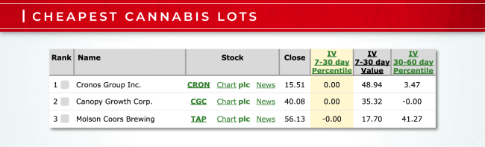

These are the three cheapest Lots in cannabis right now.

Now, here's another chart with the three most expensive Lots…

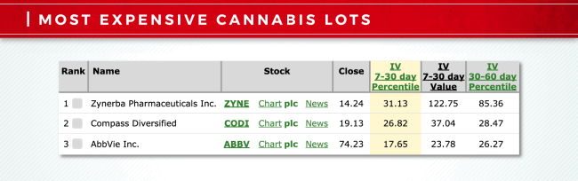

And you want to be buying the cheap ones obviously and selling the most expensive ones.

**Fourth is what I call Payday Alerts.**

These are repeating price patterns in specific companies that show up over and over and over again.

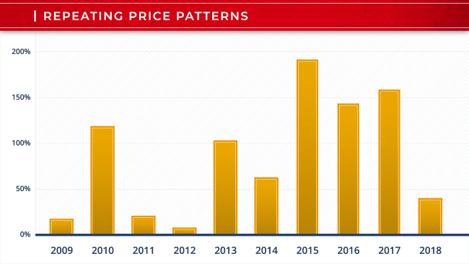

In fact…

**Our data shows that these patterns work 90% of the time.**

It's as predictable as death and taxes.

**Finally, there are Earnings Patterns.**

These tell us what stocks to buy, exactly what day I want to be buying them, and what day I want to be selling them.

Take a look at this play.

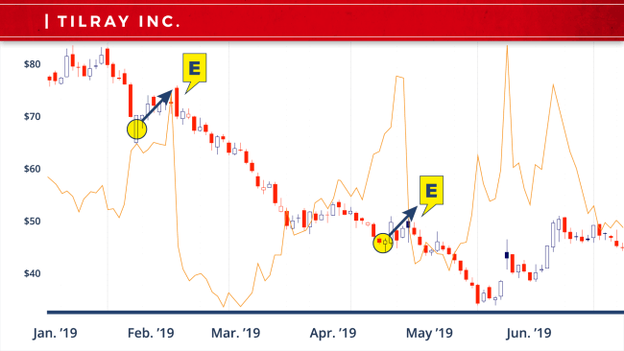

One week before earnings, this Lot has a history of going higher, and we want to capitalize on that.

**My system combs through all of these Cannabis Lot offerings every single day, running all of these patterns.**

**It's looking for the perfect match between the lot and the strategy.**

**When it finds it, it's go time.**

**JOHN:**

So what does it take to track these kinds of patterns?

**TOM**:

Well the short answer is, it takes an army of rocket scientists…

**My team has a combined 112 years’ experience.**

These guys climbed the ranks at organizations like NASA, Texas Instruments, and Raytheon.

They spent years developing air flight control systems, missile guidance technology, as well as radar tracking devices.

My chief scientist and lead programmer, John Sanderson, has 44 years of software-development experience.

**Between them, they hold 11 patents issued by the U.S. government.**

**JOHN:**

What about the hardware?

**TOM**:

For people who know me or have been in my command center…

They know that…

**No one has the amount of data power and fire power that I have.**

**I’m locked into every exchange in the world.**

My system operates at 15.8 gigaflops, meaning it can conduct a staggering 15.8 billion calculations per second.

**And it possesses a proprietary sequence-matching protocol that can spot hidden trading patterns that are invisible not only to the human eye but to every other computerized trading platform on the planet.**

Because of this unprecedented combination of raw computing power, blazing processing speed, and other-worldly intelligence…

I can give folks who are following me access to opportunities that no one else sees.

**JOHN:**

Tom, obviously your systems are working.

I mean, folks following you have been raving about how they’ve been making $20,000… $40,000… $100,000… or more.

**TOM**:

And because of the massive growth in the cannabis industry right now, I think the gains here could be even bigger.

In fact…

**I fully expect we could see a string of 1,000% gains one after the other.**

We’ve already seen a 22nd Century Group Cannabis Lot grow 1,200%...

An MJ Alternative Harvest Cannabis Lot jump up 1,960%...

And a GW Pharmaceuticals Cannabis Lot shoot up 3,400%.

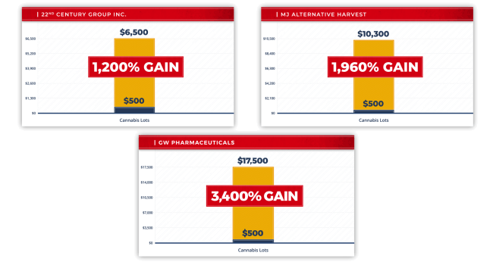

But it’s not just about the 1,000% gains…

It’s also about making sure this strategy can be used by ordinary investors.

That’s why I kept the price per lot down to an affordable average of only $496.

I wanted to make sure this was fast cash without taking any big risks.

But there’s another reason why I’m so excited about these Cannabis Lots…

Because it’s not only the cannabis growers who are offering these Cannabis Lots…

Pharmaceutical companies are now offering Cannabis Lots too.

**JOHN:**

Tom, I’m not surprised by that at all.

At the*National Institute for Cannabis Investors*, we’ve talked a lot about the medical applications for cannabis.

**There have been more than 23,000 scientific papers released on the medical benefits of cannabis therapies.**

Alzheimer’s, cancer, epilepsy, post-traumatic stress disorder, autoimmune diseases… the list goes on and on.

Tom, I know this is a big reason why you started your own growing operation.

So that you could help veterans and others suffering from PTSD.

**TOM**:

Absolutely – cannabis can have a transformative effect on medicine.

And new companies are constantly being created to take advantage of it.

These new companies are offering Cannabis Lots too.

I’m tracking six of them already.

**Take AbbVie for example.**

AbbVie developed a marijuana-based compound that helps cancer patients struggling with nausea from chemotherapy.

In January, you could have purchased a handful of AbbVie Lots for only $520.

Then, you could have turned right around and sold them only two days later for $9,040.

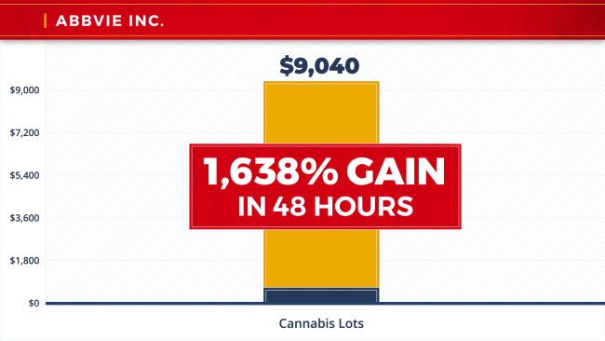

**That’s 1,638% gains in 48 hours.**

**Or consider Cara Therapeutics.**

Cara is developing a new cannabis treatment for chronic pain.

It could help prevent thousands of opioid overdoses every year.

In March, you could have purchased 30 Cara Lots for $450.

And you could have sold them a week later for $6,750.

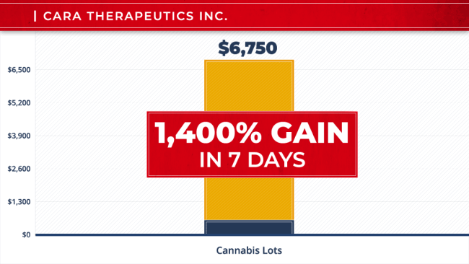

**That’s a 1,400% gain in only seven days.**

And don’t forget GW Pharmaceuticals.

**JOHN:**

Absolutely, Tom.

GW was the first company to get FDA approval for their breakthrough new cannabis drug.

It stops seizures in people suffering from epilepsy.

**TOM**:

That’s right.

Back in January, they were offering Cannabis Lots for just a dollar.

A $500 investment would have grown to $17,500 in a single day.

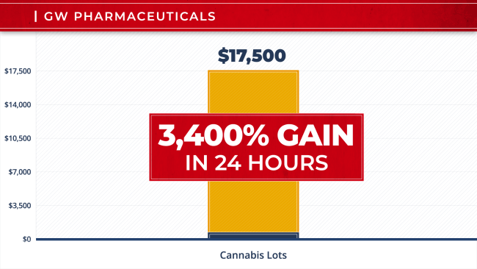

**That’s a 3,400% return in 24 hours!**

And it’s not just pharmaceutical companies…

Alcohol and tobacco companies are getting into cannabis too.

**JOHN:**

You’re right.

At The Institute, we’ve been tracking that closely.

Cannabis is the biggest threat to the alcohol industry.

So beverage companies have been trying to hedge their bets.

They’re making deals left and right.

**Eight out of 10 consumers already report they are drinking less alcohol and replacing it with cannabis.**

As more states legalize cannabis use, this trend will only continue.

**Which is why Legacy Beverage companies are all rushing to develop cannabis-infused drinks.**

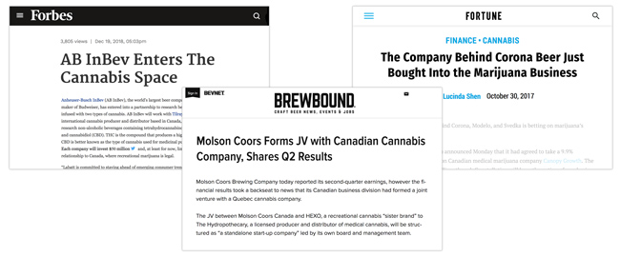

Constellation Brands, the maker of Corona and Modelo, grabbed a $191 million stake in Canopy Growth.

Molson Coors teamed up with cannabis producer HEXO.

And Anheuser-Busch inked a deal with Tilray.

**TOM**:

The SEC allows Cannabis Lots on these guys too.

And they’re just as explosive as the cannabis growers and pharmaceutical companies.

**Take Molson Coors for example.**

In December, you could have purchased 30 Lots for $540.

Then, you could have turned around and cashed them in for $8,280 only four days later.

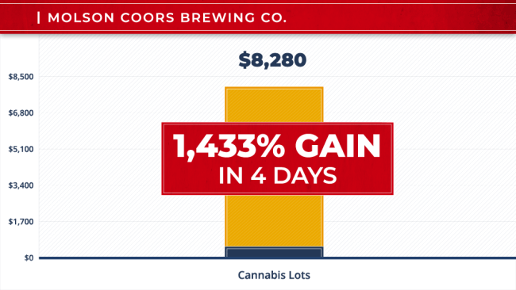

**That’s a 1,433% gain in less than a week.**

Or you could have purchased Anheuser-Busch Lots for $420 in January.

Those would be worth $6,420 two days later.

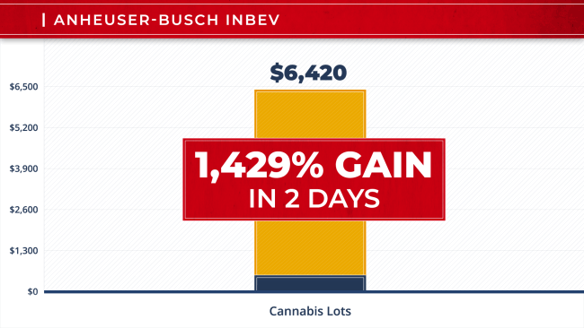

**That’s a 1,429% profit.**

Or you could have grabbed Constellation Brands Lots for $500 on January 17.

And you could have pocketed $17,000 just 24 hours later.

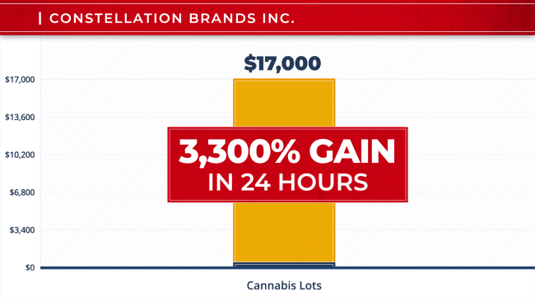

**That’s a 3,300% gain in a single day.**

Where else are you going to see those kinds of returns?

**JOHN:**

Nowhere that I’ve seen before.

And beer companies aren’t the only brands jumping on the cannabis bandwagon.

Scotts Miracle-Gro teamed up with a Canadian producer to test their grow lights and fertilizers on cannabis plants.

And Altria bought a 45% stake in Cronos Group.

People can now trade Cannabis Lots on all these companies as well.

And that means even more opportunities to profit.

**TOM**:

That’s right.

**My system is tracking all of these Lots right now.**

And the gains here… they aren’t just great; they can be extraordinary… especially when you consider these returns are coming from brands that were considered DOA just a short time ago.

Take tobacco giant Altria…

On January 24, you could have invested $450 in Altria Lots.

And you could have sold them only eight days later for $9,900.

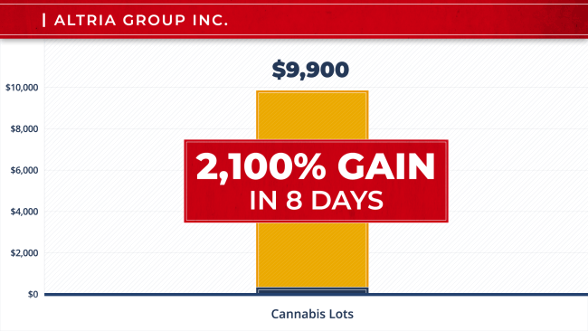

**That’s a 2,100% gain.**

That same day, you could have put $500 into Philip Morris Lots.

And you could have flipped them a day later for $10,500.

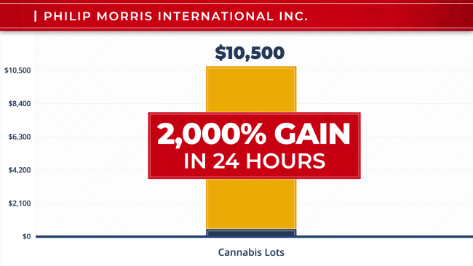

**That’s a 2,000% gain.**

Four days later, you could have invested $500 in British American Tobacco Lots.

Then, you could have turned around and sold them for $17,000 a couple of weeks later.

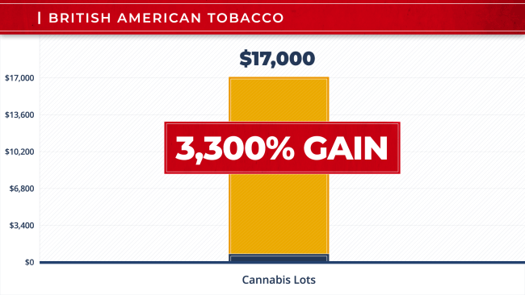

**That’s another 3,300% gain.**

These are certainly rare and exceptional – the kinds of returns you do not see every day.

**But those opportunities were all just initiated in January alone.**

**JOHN:**

That’s a pretty good January.

So you’re going back to them over and over.

**TOM**:

That’s right.

**With new Lots released every week, there are plenty of chances to profit.**

And that means we can go back to the same companies and trade their Cannabis Lots week after week after week.

**Take Altria as an example…**

Since these Lots became available for sale in December, you could have snagged lots for $480 and sold them for $5,400 the next day.

In January, you could have come right back and grabbed Altria lots for $450.

Eight days later, they were worth $9,900.

And you could have gone to the Altria well again in February…

Grabbing Lots for another $450 and selling them for $9,550 just three days later.

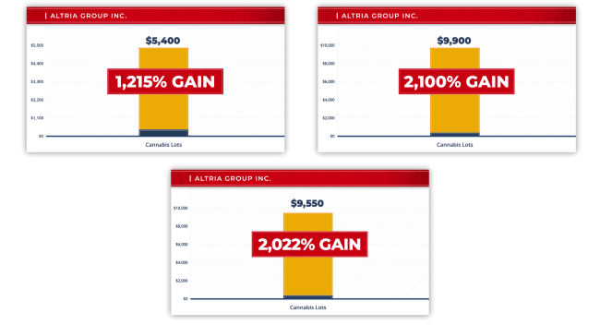

**That’s $24,850 in total gains from only one company in three months!**

**JOHN:**

And you can do this with every company that offers these Cannabis Lots…

**TOM**:

That’s right.

**Let’s look at another company, Cara Therapeutics.**

You could have scooped up $500 in Cara Lots in December and sold them for $12,500…

Then, you could have turned right around and bought another $500 worth of Cara Lots and sold them in January for $7,500.

And then again in March, you could have grabbed another $450 in Cara Lots and pocketed $6,750 in a week.

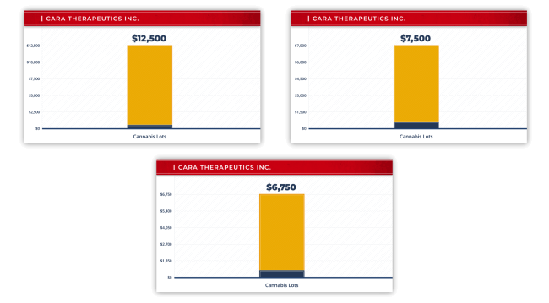

**Add it all up, and you could have just pocketed $26,750 in gross profits from just three sales.**

**JOHN:**

That’s fascinating; give me another one.

**TOM**:

Sure, take a look at Canopy Growth…

As I showed you earlier, you could have invested $500 in Canopy’s Lots in December and pocketed $6,844 less than three weeks later.

Then, you could have jumped back in and invested $500 in more Lots in January… and walked away with $24,500 in just three days.

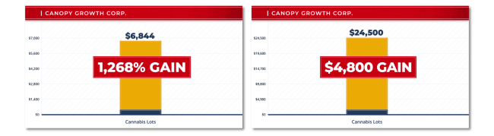

**That’s over $31,000 from only two investments.**

**JOHN:**

That’s incredible…

* Cronos…
* Aurora…
* Tilray…
* GW Pharmaceuticals...

These companies all offer new Lots every single week.

**TOM**:

Every Thursday at 9:30 a.m.

**Every single week, my system is designed to tell me that one of these Lots is ready to pop and deliver a fast profit.**

Look: I’ve been following the cannabis industry for years.

I’ve been making a living as a trader for decades now.

**I’ve never seen this many BIG opportunities this close together.**

**These Cannabis Lots can be a game changer.**

This is so new, very few folks know about them yet.

Once word gets out, I expect everyone will be jumping on the bandwagon.

**But right now, there’s a rare opportunity for ordinary investors to get rich by taking advantage of these Cannabis Lots.**

**JOHN:**

Well Tom, that’s why we have a very big announcement to make.

You’re one of our newest board members.

And you’re the first person to introduce us to these Cannabis Lots.

**So you’ve agreed to team up with us to launch an exciting new pilot program.**

**You’re going to teach a group of ordinary folks how to trade Cannabis Lots the way you do.**

You’re going to show them exactly how your system works…

How it has the power to identify *which* lots can break out for a 300%... 500%... even 1,000% or better profit in just a few days or weeks.

**We’re calling this pilot program *Cannabis Power Trader*.**



But that’s not all…

We’re also going to do something we rarely do.

We’re giving $1.5 million in funds to our initial participants.

I’ll talk more about that in a second.

First, Tom, I want to dive into how your new initiative is actually going to work.

**TOM**:

Sure thing, John.

**I want to take a small group of folks and show them exactly how to make a lot of money with Cannabis Lots.**

**We already have the first Lot lined up and ready to go.**

After that, they’re going to be coming in one after the other, week after week.

Some weeks, my system might identify two or three.

Some weeks, I may not have one at all.

**I’m looking to make 52 Cannabis Lot recommendations over the next year.**

So every seven days on average, you’ll have the opportunity to turn a small grubstake, around $500 or less, into $5,000, $10,000, potentially even $50,000 or more.

**And with the kind of explosive growth we’re seeing in the cannabis industry right now, I anticipate we could see more new opportunities this year than we’ve ever seen before.**

Because look: The cannabis industry is growing faster today than at any time to date.

Retail sales grew 35% so far this year, and the year is only half over.

We’ll likely blow past $20 billion by the end of the year.

**JOHN:**

And that’s without federal legalization!

**TOM**:

Exactly.

**The opportunities here? They are plentiful and multiplying.**

And when one of these company Lots comes up for sale, and my system tells me it has the kind of big-money potential we’re looking for…

**I’ll send you a Cannabis Lot Alert.**

Here’s one for the Aurora Cannabis Lot my testing just uncovered.

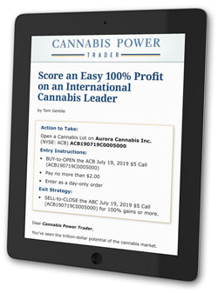

**I give you the company name, the exact Cannabis Lot number, the time frame for buying and selling…**

**And the simple step-by-step instructions.**

Now, these Cannabis Lots are traded on all the major trading platforms.

So there’s nothing new to learn there.

If you want…

You simply follow my instructions with a few mouse clicks, and you’re done.

Of course, if you want all the research and analysis behind the trade before you make your decision… I’ve got you covered there too.

You can see exactly what my system is showing me…

Why it’s predicting a big move on this particular lot… and how long it will take to play out.

You’ll get all the charts and background any data geek like me would love.

**And my team and I will manually review each and every play to make sure it has the kind of potential we’re looking for.**

As I said, the first Lot is ready and waiting for your review right now.



And because we all lead incredibly busy lives, and no one wants to sit in front of their computer waiting for an Alert…

Whenever I release a Cannabis Lot Alert, I’m more than happy to shoot you a quick alert on our custom app.

That way, if you’re on vacation, enjoying a round of golf, or out to lunch, you won’t miss any of the action.

**Trading these Lots is so easy, you can do it right from your phone.**

**JOHN:**

Tom, that sounds great, but what if someone is a complete novice, and they know nothing about Cannabis Lots?

**TOM**:

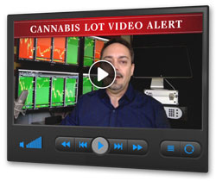

John, everyone is a novice when it comes to many of these Cannabis Lots.

Because they simply weren’t available to trade before.

**That’s why I’m also going to record a companion Cannabis Lot Video Alert of me or one of my team members demonstrating placing the trade on one of these platforms.**

As soon as an alert goes out, we’ll follow up right away with a video.

**You can look over my shoulder as I show members exactly how to buy and sell these Lots…**

And again, you can simply open the email on your cell phone and watch the video wherever you are.

**JOHN:**

Now Tom, I just have to ask.

You told me that these Cannabis Lots are a special kind of option.

You showed me how these little-known options let ordinary investors have the chance at explosive returns.

But what if I’ve never traded options before?

Can ordinary investors really do this?

**TOM**:

I’ll tell you what my mom used to say to me, “You’ll never know until you try.”

What if I’d never placed my first trade?

What if I’d never put myself out there and tried?

I might still be working some dead-end job living paycheck to paycheck, and I might never have achieved the incredible success or enjoyed the lifestyle I’m so grateful to have today.

**That’s why I created my Cannabis Lots Masterclass.**

**I took everything I’ve learned in my 35-year career as a trader and broke it down into a series of 10 simple lessons – each less than five minutes.**

**JOHN:**



And this isn’t some ivory-tower class with confusing Greek terms where you need a scientific calculator.

**This video series is for ordinary folks who want to become expert traders – fast.**

**TOM**:

Exactly.

You’ll learn how to get your trading account set up, including common mistakes to avoid and step-by-step directions on how to do it correctly.

So you can start trading Lots and pocketing any gains immediately.

You’ll also get a list of the basic terms and lingo so you’re confident when placing a trade.

You get detailed line-by-line, click-by-click directions on…

* How to buy Lots…
* How to sell Lots…
* And how to track your returns.

**JOHN:**

Plus, you get a new Cannabis Lot recommendation immediately, so you can get started right away.

**The video series also includes a companion guide you can print out and follow along.**

**TOM**:

Right, you get a list of dos and don’ts when trading options that can save you a world of pain.

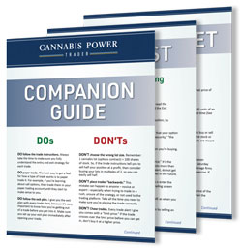

You get a simple check list you can post above your desk so you never miss a step when buying and selling lots.

You get a cheat sheet of terms to use when calling your broker so you’ll sound like an expert in no time.

Best of all, you can get through the entire Masterclass in less than an hour, start to finish.

And did I mention it was easy?

**JOHN:**

In fact…

**We're so confident anyone can do this that The Institute is putting up $1.5 million in funds to prove it.**

That’s a lot of money on the line.

**TOM**:

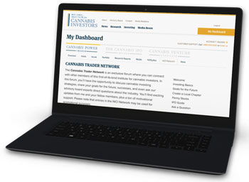

Look, this is about being part of a team.

I always tell my own team, “No one trades alone.” We’ve got each other’s backs.

That’s why I created the **Cannabis Trader Network**.

This is where members can post questions… hash things out… or even share what they are learning with each other.

**This is about sharing knowledge and resources so everyone can succeed faster.**

And if you want to take it to the real world, you can.

You can arrange meet ups in Sarasota, Cincinnati, Topeka – anywhere you want.

Start your own live and in-person local chapter of the **Cannabis Trader Network**.

Grab a beer or glass of wine and network with each other.

**The Wall Street fat cats have been taking advantage of this kind of insider’s network for decades.**

**Now, it’s your turn.**

**JOHN:**

Tom, the cannabis market is skyrocketing right now with new Cannabis Lots becoming available for trading almost every day.

As a reporter, I know what it takes to keep up with an economic revolution the size and scope of this one.

How are you going to keep folks abreast of the rapid changes in this industry?

**TOM**:

I’m glad you asked.

I’m going to be hosting a quarterly **Cannabis Trader Mastermind**.



This is an exclusive online, closed-door meeting for members ONLY where I’ll share progress reports and update members on all the latest developments, like new Cannabis Lots that become available for trading.

2018 was a banner year for cannabis companies..

And dozens of companies are right now waiting in line for the SEC to allow them to issue Cannabis Lots.

This lineup looks good, and I can’t wait to share it with our members because…

**This is the kind of intel you’ll never find on Google.**

I want everyone to be in the loop.

And I want to get to know the group.

I want to hear how everyone is doing.

And I want them to get to know me.

Plus, you know how much I love teaching and trading, so I’ll probably throw in a few special training sessions and bonus plays too.

I’m really looking forward to hosting the first one.

**JOHN:**

That’s quite the lineup, Tom.

Let me summarize.

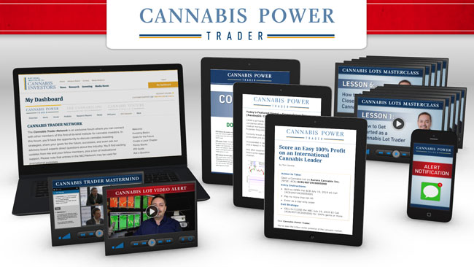

You get…

Tom’s weekly Cannabis Lot Alerts.

His system pinpoints the best Cannabis Lot opportunities every week, and then…

**Tom reviews and assesses every trade to make sure it meets his strict criteria. Every single one.**

Then, and only then, does he send out the email and training video with the recommendation.

**And again, you can also receive instant notifications via our custom app when new Lot opportunities are released.**

**You get Tom’s 10-part Cannabis Lots Masterclass based on 35 years of experience and training thousands of individuals on how to successfully trade options.**

That hard-won knowledge and wisdom alone is worth $5,000…

But members get it absolutely free.

**You get access to the Cannabis Trader Network, where you can accelerate your learning, benefit from new connections, and share resources.**

And you get quarterly custom briefings live and online in the **Cannabis Trader Mastermind**.

I know folks like me who would have paid $25,000 a year to be in a high-level seminar like that.

When you think about it – that’s an incredible opportunity all on its own.

**We’re talking about well over $30,000 worth of value to be a part of this pilot program.**

**And that doesn’t even count the $1.5 million in funds.  
TOM**:

Now, just to be clear, we’re not going to charge that much.

In fact, nowhere near that.

But I will say this right now…

And it’s part of my goal…

**I’ve designed this so that from the very first trade, folks could easily pay for this service twice over… three times over… possibly even more.**

Plus, we are so sure of this system, we’re putting up $1.5 million in funds.

**JOHN:**

That's right.

Let me explain how that works.

**We’re opening this pilot program to 600 people today.**

If you’ve followed Tom at all, you know that this can be like shooting fish in a barrel.

Every day, we get emails and letters from folks letting us know how grateful they are for the opportunities Tom has showed them.

**A lot of people are making $5,000… $10,000… even $20,000 or more *per trade*…**

Jim Smoot tells us he made $15,005 on just one play.



Don Edwards made $25,000 in just a couple months.



And some of Tom’s other members are doing even better.

Joe Willis says he made $70,000 in just the first month of following Tom.



Jane Hollice tells us she made about $107,000 following Tom’s recommendations and was able to help pay off her house.

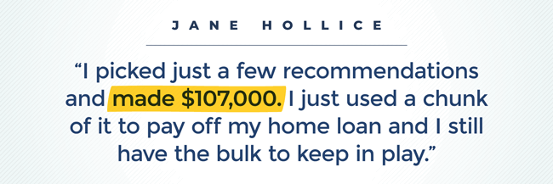

Then there’s Steve Carter.

He started following Tom’s recommendations two years ago with just $500.

He turned that into over $127,000 and bought a supercharged Chevy.

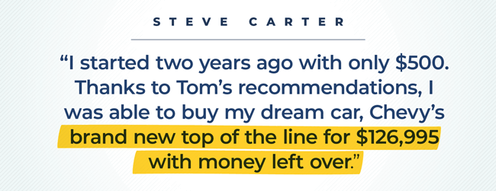

For anyone else, I’d say these kinds of returns look impossible.

But you’ve seen Tom’s win rate.

**I'm here to tell folks that you don't have to settle for mediocre returns.**

**TOM**:

Just remember: These Cannabis Lots are new.

Most investors haven’t heard of them yet.

I believe we are in the “sweet spot” right now, where early-in investors could see gains like…

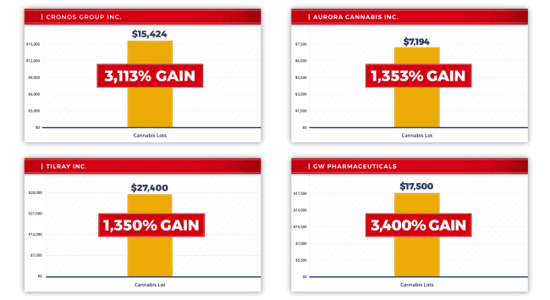

Over 3,000% on Cronos Lots…

Over 1,300% on Aurora Lots…

Another 1,300% on Tilray Lots...

And 3,400% on GW Pharma Lots.

**Those kinds of plays could make someone thousands, maybe even hundreds of thousands of dollars.**

Of course, there are no guarantees in the market.

No one has a crystal ball to predict the future, so just because we did this well in the past does not guarantee the future.

But with my system, my research, and my recommendations…

**I’ve never been more confident that we’re gonna rip this market open like never before.**

**JOHN:**

Which is why you're not going to pay $30,000 to take part in this pilot program.

You're not even going to pay $10,000.

Today, you can get access to…

**Tom Gentile’s *Cannabis Power Trader*for just $4,950.**

**As soon as your slot is secured, we’ll give you a $2,500 discount, so all you pay is $2,450.**

**TOM**:

Now John, that’s an incredible deal.

**JOHN:**

It certainly is, Tom.

Now before we move on, I want to quickly talk about your goal for this research service.

Because frankly, it’s pretty ambitious.

**TOM**:

It’s not just my goal.

It’s my guarantee.

Look John; we’re obviously going to offer folks our standard money-back guarantee.

But frankly, just getting your money back doesn’t help you grow your wealth… or pay for your kid’s college fund.

It just gets you back to breaking even.

That’s why I’m not stopping there.

My goal is much, much bigger than breaking even.

**JOHN:**

That’s right; you’re making your 12,000% guarantee.

**You’re promising to deliver *at least 12* different 1,000% winners over the next 12 months, or we’ll work for free.**

You’ll give folks an extra year of ***Cannabis Power Trader*** on the house.

**TOM**:

I don’t want to sound too cocky, John…

But from what I’m seeing with these Cannabis Lots, I think we should be able to blow past that goal.

**We could hit one or two 10-baggers a month.**

**JOHN:**

Tom, can I get you to push that one step further?

Because those giant gains are great, but what impresses me so much about your system is how little it loses.

**So far this year, you’ve delivered an 87% win rate on your normal stock recommendations in your current research services.**

**And then you topped that with a 100% win rate on your closed plays on some of the most speculative cryptocurrency recommendations since you began trading them a year ago.**

So here’s what I want to know…

**Can you promise folks that you’ll deliver a 90% win rate or better with the *Cannabis Power Trader*?**

And if you don’t deliver, would you consider making the same offer…

Working for your members for an extra year for free?

**TOM**:

What the heck, John.

I’m up for the challenge.

I just need to make one thing clear…

I don’t have a whole lot of room in this pilot program.

I only want a small group of super-committed people.

That’s one reason we’re offering this first group such a great discount.

**JOHN:**

Alright, let’s go over what folks are getting again.



* 52 weeks of Cannabis Lot recommendations with the potential to deliver 1,000% or even bigger gains…
* A real-time video of Tom or one of his team members walking you through each and every play…
* Tom’s **Cannabis Lots Masterclass** that distills his 35 years of trading experience into 10 essential lessons designed to turn even novices into expert traders in a matter of days…
* The **Cannabis Trader Network***.* This is where you can hang out with your fellow members and talk shop…
* The **Cannabis Trader Mastermind**seminar where Tom, you, and your fellow members are going to be pushing the limit on optimizing Cannabis Lots for even bigger profits…

So…

**If you're ready to get started, the time is now.**

Click on the button below.

You’ll be taken to a secure page where you can see all the details of this pilot program.

But please do it now.

**With an amazing 100% satisfaction guarantee and a price almost too good to be true, there’s little time to waste.**

Tom, I can’t thank you enough for sharing this with us today.

**TOM**:

John, it’s been fun.

As you can tell, I’m pretty fired up about this new way folks can make money from cannabis.

I’m looking forward to getting started.

**JOHN:**

And thank you folks for joining us today.

**Today could be your only chance to ride along with Tom with the potential to build extraordinary wealth in the hottest, fastest-moving industry in America today.**

**But please note: This opportunity is limited to the first 600 people today.**

So don’t waste a minute.

The risk of missing out is real.

**Any delay could cost you thousands and thousands of dollars.**

So please click the button below now, and see everything you could be getting.

If you have any questions about the service and how it will work for you, I encourage you to contact our reliable Member Services team at 866.298.7257 or 443.380.2078 (for international calls) and mention Priority Code: ECPWV700.

Thank you for watching today.

For the *National Institute for Cannabis Investors*, I’m John Burke.

[**JOIN NOW**](https://pro.nicinvestorsinfo.com/o/CPWLNC2/ECPWV700?h=true&fbclid=IwAR3F_puZt2ckQ4Y3ClK3B8SMPPRB3PEf4Wh3suH-mmk8ofucsXuh4jNXojo)

Copyright – 2019 National Institute for Cannabis Investors, LLC. Legal Notices: In order to ensure that you are utilizing the provided information and products appropriately, please be sure to visit National Institute for Cannabis Investors [disclaimer](https://nicinvestors.com/terms-and-conditions/) and [privacy policy](https://nicinvestors.com/privacy-policy/) pages.

